CSCD327 – Lab3

1) Note: I am using varchar for COMM

select *

from EMP

where (DEPTNO = 10) or (COMM != '') or ((DEPTNO = 20 and SAL <= 2000));

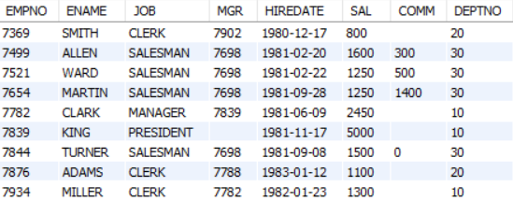

2)

select ENAME, JOB

from EMP

where DEPTNO = 10;

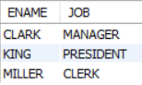

3)

select CONCAT(ENAME, ' WORKS', ' AS', ' A ', JOB) as 'Works_As'

from EMP

where DEPTNO = 10;

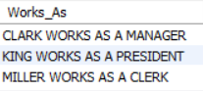

4)

select ENAME, SAL,

case

when SAL <= 2000 then 'UNDERPAID'

when SAL >= 4000 then 'OVERPAID'

else 'OK'

end as 'STATUS'

from EMP;

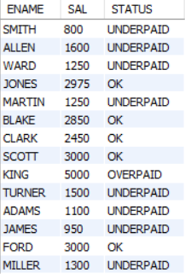

5)

select ENAME, JOB

from EMP

where (DEPTNO = 10 or DEPTNO = 20) and (ENAME regexp 'i' or JOB regexp 'er$');

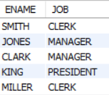

6)

select ENAME, JOB

from EMP

order by substr(JOB, length(JOB) - 2), JOB DESC;

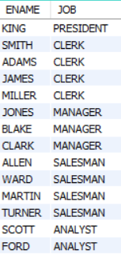

7)

select title, category

from BOOKS

where category != 'FITNESS';

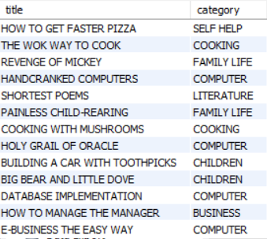

8)

select Customer_num, LastName, State

from CUSTOMERS

where state = 'GA' or state = 'NJ'

order by LastName ASC;

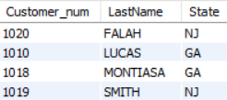

9)

select lname, fname

from AUTHOR

where lname regexp 'IN'

order by lname;

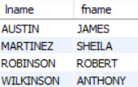

10)

select isbn, title

from BOOKS

where title regexp '^.A.N'

order by title DESC;



11)

select concat(last_name, ', ', first_name) as full_name

from customers

where last_name not between 'a' and 'n'

order by last_name ASC;

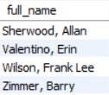

12)

select

product_name, list_price, discount_percent,

round(list_price * (discount_percent / 100), 2) as discount_amount,

round(list_price - list_price * (discount_percent / 100), 2) as discount_price

from products

order by discount_price DESC;

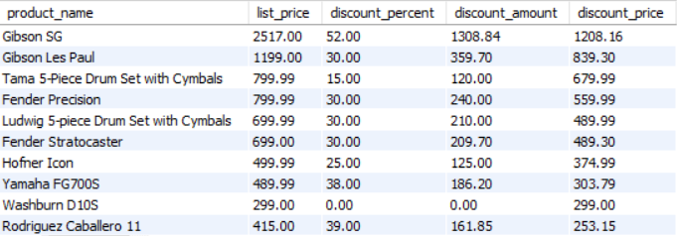

13)

select

item_id, item_price, discount_amount, quantity,

(item_price * quantity) as price_total,

(discount_amount * quantity) as discount_total,

((item_price - discount_amount) * quantity) as item_total

from order_items

where ((item_price - discount_amount) * quantity) > 500

order by item_total DESC;

